**DIGITAL WATERMARKING**

Cryptography:

Clear information encrypted to something using a key and decrypted to get it back using the key.

Steganography:

Embedding a secret message into an innocent cover object. Trying to obscure there is a message present.

Watermarking:

In between cryptography and steganography. Embed information into an image so that:

* Image seems unchanged
* Watermark can be extracted even after processing
* Removing the watermark should destroy the image.

TV channels have watermark.

Movies and images (currencies and bills) have special dots which capture information upon being recorded or stored.

***Insertion/embedding***:

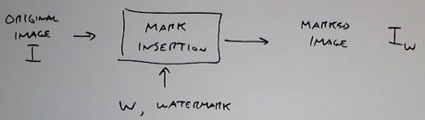

***Detection***:

